**DevOps Assignment Deliverables**

GitHub Link: <https://github.com/pavansy6/python-microservices-devops>

1st

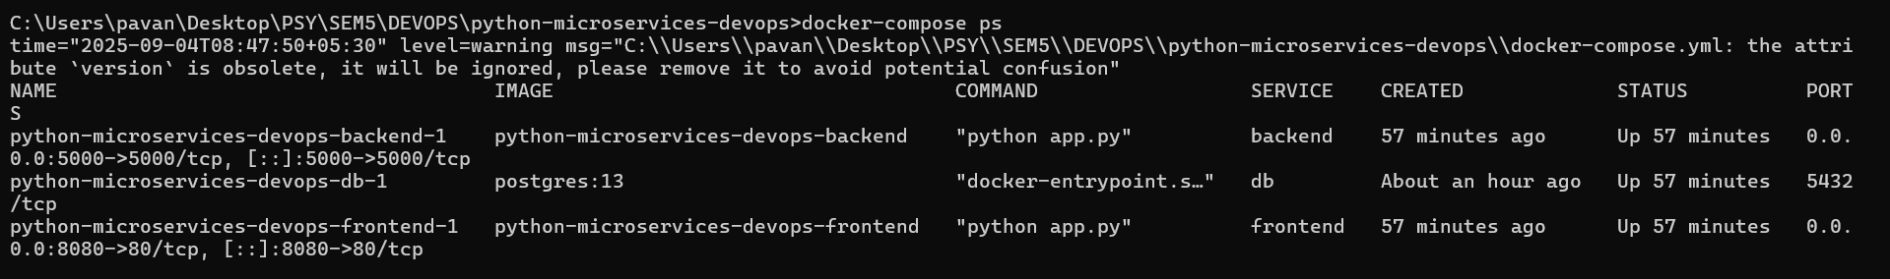

2nd

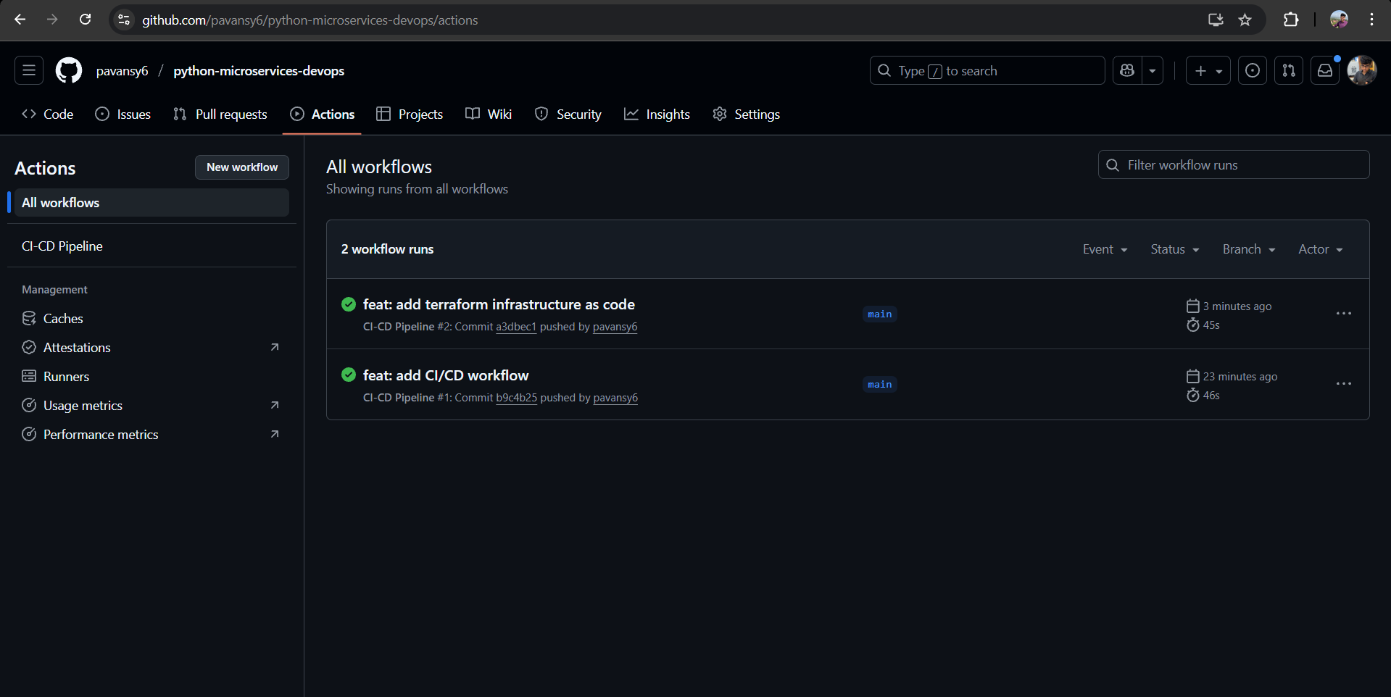

3rd

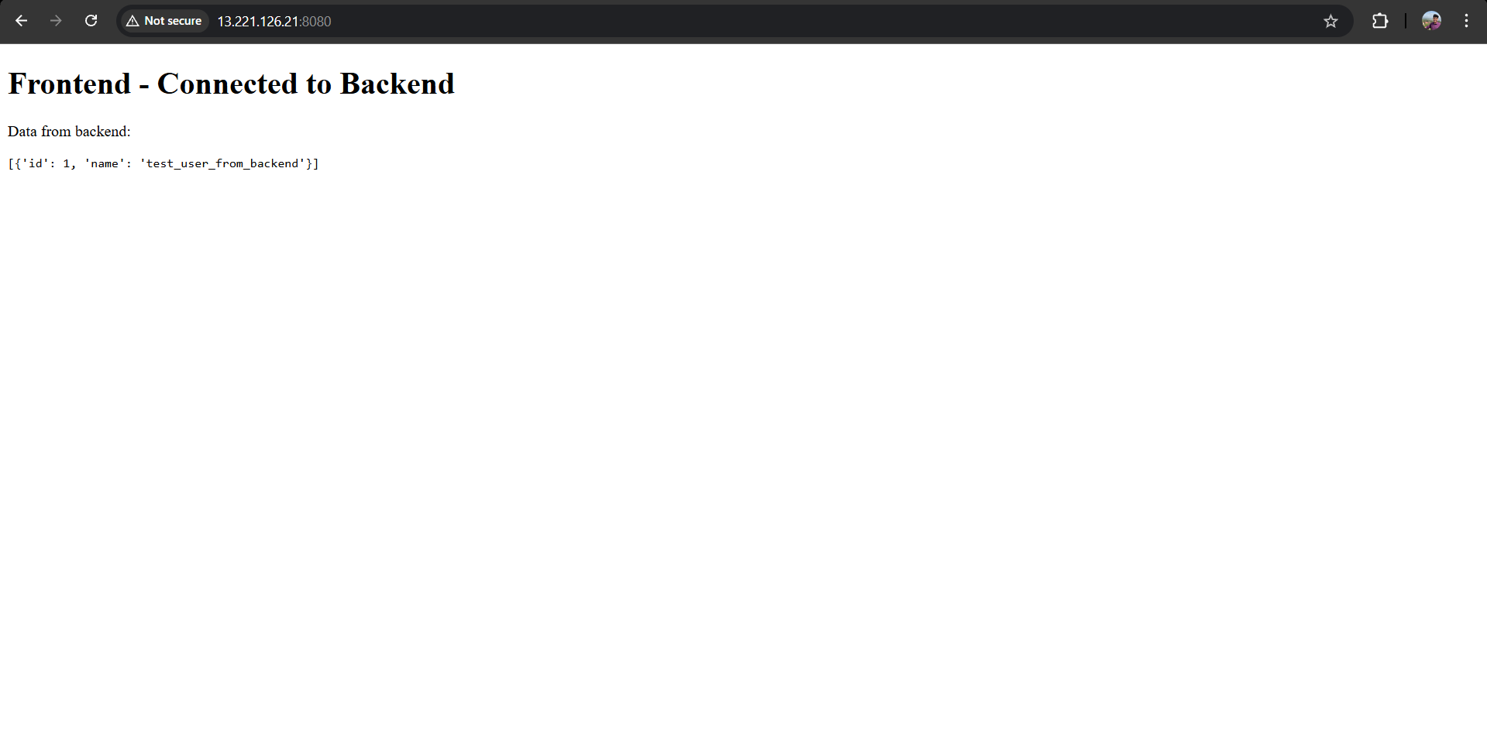

1. What was the hardest part?

The hardest part was figuring out the AWS permissions error. The Terraform code was correct, but the deployment failed because the cloud user didn't have the right permissions, which required logging into the AWS console to attach the correct security policy before the server could be built.

1. How does CI/CD + IaC help reduce manual effort?

CI/CD with GitHub Actions saves time by automatically building and publishing our Docker images whenever we push code. Infrastructure as Code with Terraform lets us create and delete an entire cloud server with a single command, which is much faster and more reliable than setting it up manually through the AWS website.